19/11/2024
DSA PRACTICE DAY 7
- Next Permutation:
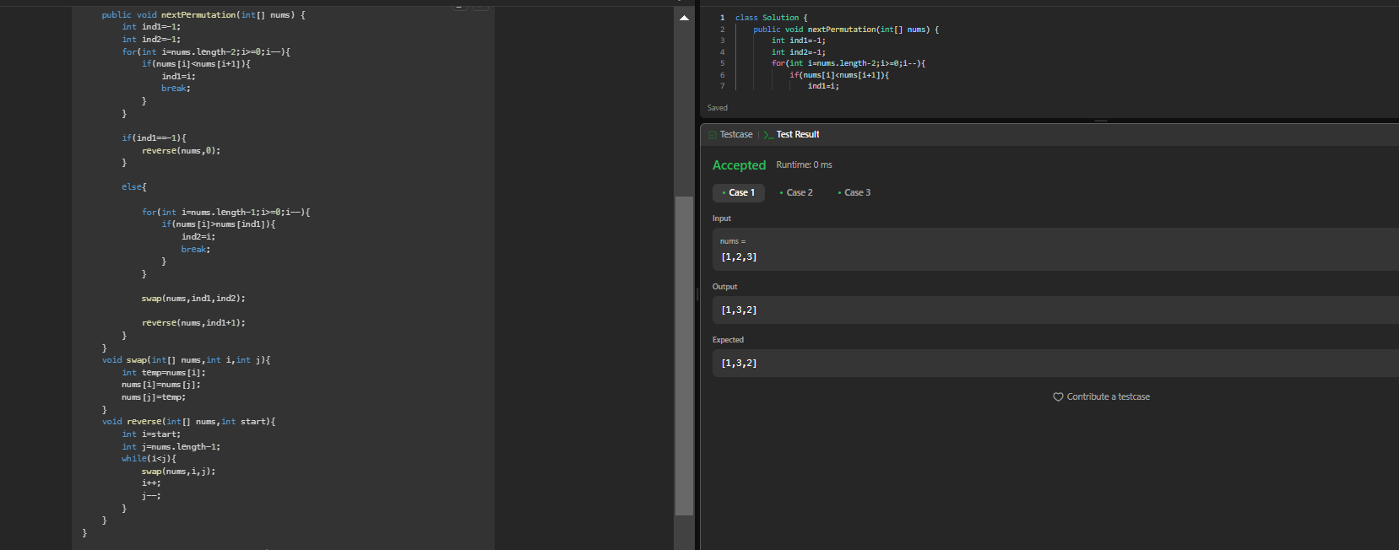
- Spiral Matrix
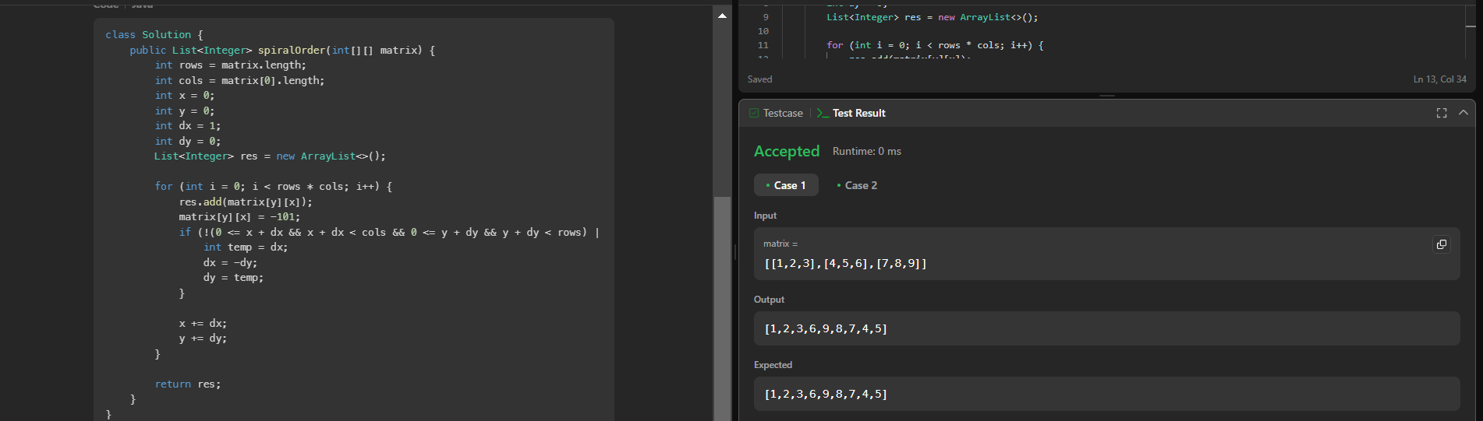
- Longest substring without repeating characters
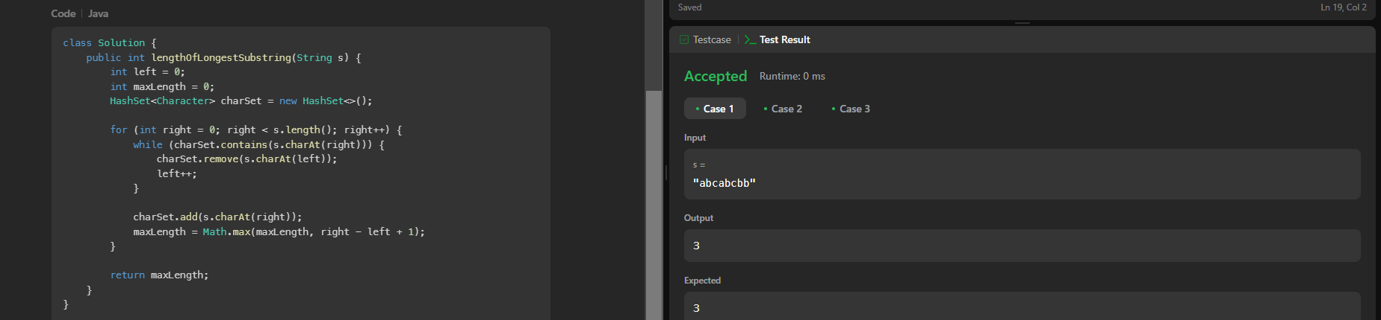

- Remove linked list elements
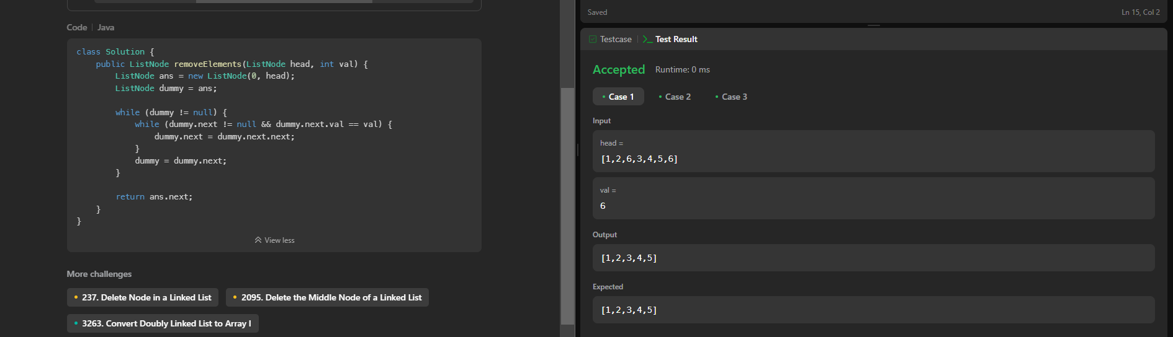

- Palindrome linked list
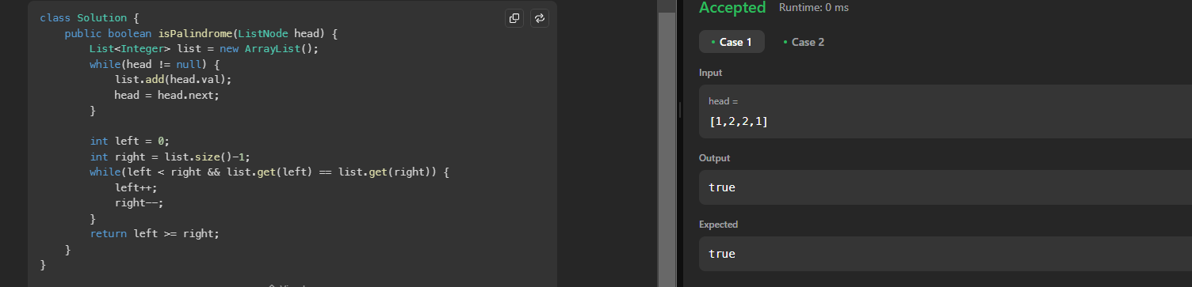
- Minimum path sum
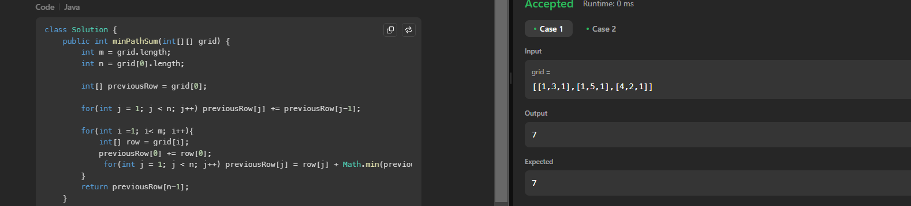
- Validate binary search tree
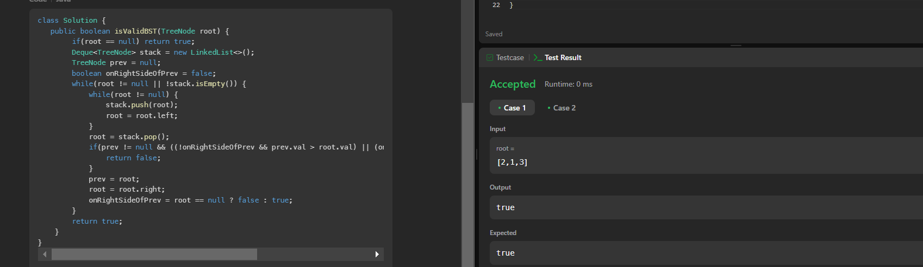

- Word ladder
Program:
class Solution {
public int ladderLength(String beginWord, String endWord, List<String> wordList) {
Set<String> wordSet = new HashSet<>(wordList);
if (!wordSet.contains(endWord)) return 0;
Queue<String> queue = new LinkedList<>();
queue.offer(beginWord);
Set<String> visited = new HashSet<>();
visited.add(beginWord);
int length = 1;
while (!queue.isEmpty()) {
int levelSize = queue.size();
for (int i = 0; i < levelSize; i++) {
String currentWord = queue.poll();
if (currentWord.equals(endWord)) return length;
for (String neighbor : getNeighbors(currentWord, wordSet)) {
if (!visited.contains(neighbor)) {
visited.add(neighbor);
queue.offer(neighbor);
}
}
}
length++;
}
return 0;
}
private List<String> getNeighbors(String word, Set<String> wordSet) {
List<String> neighbors = new ArrayList<>();
char[] wordChars = word.toCharArray();
for (int i = 0; i < wordChars.length; i++) {
char originalChar = wordChars[i];
for (char c = 'a'; c <= 'z'; c++) {
if (c == originalChar) continue;
wordChars[i] = c;
String transformedWord = new String(wordChars);
if (wordSet.contains(transformedWord)) {
neighbors.add(transformedWord);
}
}
wordChars[i] = originalChar;
}
return neighbors;
}
}

Output:
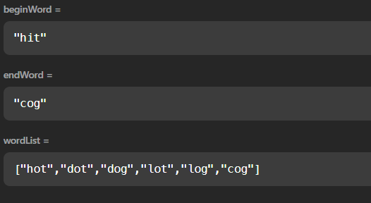

- Word ladder
Program:
class Solution {
public List<List<String>> findLadders(String beginWord, String endWord, List<String> wordList) {
Map<String,Integer> hm = new HashMap<>();
List<List<String>> res = new ArrayList<>();

Queue<String> q = new LinkedList<>();
q.add(beginWord);
hm.put(beginWord,1);

HashSet<String> hs = new HashSet<>();
for(String w : wordList) hs.add(w);
hs.remove(beginWord);
while(!q.isEmpty()){
String word = q.poll();
if(word.equals(endWord)){
break;
}

for(int i=0;i<word.length();i++){
int level = hm.get(word);
for(char ch='a';ch<='z';ch++){
char[] replaceChars = word.toCharArray();
replaceChars[i] = ch;
String replaceString = new String(replaceChars);

if(hs.contains(replaceString)){
q.add(replaceString);
hm.put(replaceString,level+1);
hs.remove(replaceString);
}
}
}
}

if(hm.containsKey(endWord) == true){
List<String> seq = new ArrayList<>();
seq.add(endWord);
dfs(endWord,seq,res,beginWord,hm);
}
return res;
}

public void dfs(String word,List<String> seq,List<List<String>> res,String beginWord,Map<String,Integer> hm){
if(word.equals(beginWord)){
List<String> ref = new ArrayList<>(seq);
Collections.reverse(ref);
res.add(ref);
return;
}

int level = hm.get(word);
for(int i=0;i<word.length();i++){
for(char ch ='a';ch<='z';ch++){
char replaceChars[] = word.toCharArray();
replaceChars[i] = ch;
String replaceStr = new String(replaceChars);

if(hm.containsKey(replaceStr) && hm.get(replaceStr) == level-1){
seq.add(replaceStr);
dfs(replaceStr,seq,res,beginWord,hm);
seq.remove(seq.size()-1);
}
}
}
}
}
Output:
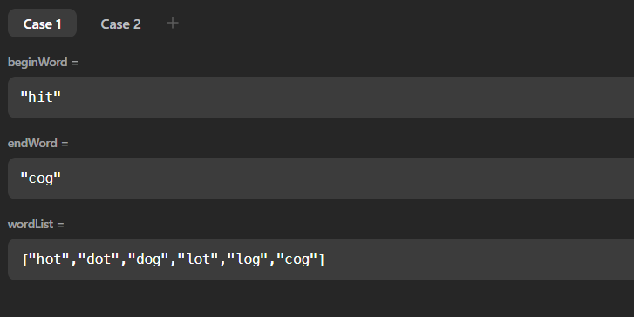

- Course schedule
Program:
import java.util.ArrayList;
import java.util.List;

class Solution {
private List<Integer> orderList;

public int[] findOrder(int numCourses, int[][] prerequisites) {
orderList = new ArrayList<>();
if(canFinish(numCourses, prerequisites)) {
return orderList.stream().mapToInt(i -> i).toArray();
} else {
return new int[]{};
}
}

public boolean canFinish(int numCourses, int[][] prerequisites) {
ArrayList<Integer>[] adj = new ArrayList[numCourses];

for (int i = 0; i < numCourses; i++) {
adj[i] = new ArrayList<>();
}

for (int[] pre : prerequisites) {
adj[pre[0]].add(pre[1]);
}

int[] visited = new int[numCourses];

for (int i = 0; i < numCourses; i++) {
if (!dfs(i, visited, adj)) {
return false;
}
}

return true;
}

public boolean dfs(int node, int[] visited, ArrayList<Integer>[] adj) {
if (visited[node] == 1) {
return false;
}

if (visited[node] == 2) {
return true;
}

visited[node] = 1;

for (int n : adj[node]) {
if (!dfs(n, visited, adj)) {
return false;
}
}

visited[node] = 2;
orderList.add(node);

return true;
}
}

Output:
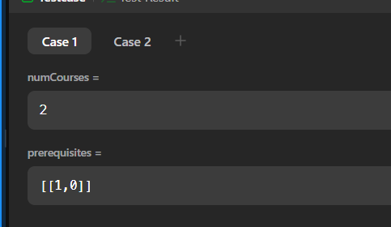
- Design tic tac toe:
Program:
class Solution {
public boolean validTicTacToe(String[] board) {
int[] arr=new int[2];
boolean xwin=false,owin=false;
int xdiag=0,odiag=0;
for(int i=0;i<3;i++){
int x=0,o=0;
for(int j=0;j<3;j++)
{
if(i==0){
if(board[i].charAt(j)=='X' && board[i+1].charAt(j)=='X' && board[i+2].charAt(j)=='X')xwin=true;
if(board[i].charAt(j)=='O' && board[i+1].charAt(j)=='O' && board[i+2].charAt(j)=='O')owin=true;
}
if(board[i].charAt(j)=='X'){
if(i==j)xdiag++;
arr[1]++;
x++;
}
else if(board[i].charAt(j)=='O'){
if(i==j)odiag++;
arr[0]++;
o++;
}
}
if(o==3 && owin)return false;
if(owin && xwin)return false;
if(x==3)xwin=true;
else if(o==3)owin=true;
}

if(xdiag==3)xwin=true;
if(odiag==3)owin=true;

if(board[0].charAt(2)=='X' && board[1].charAt(1)=='X' && board[2].charAt(0)=='X')xwin=true;
if(board[0].charAt(2)=='O' && board[1].charAt(1)=='O' && board[2].charAt(0)=='O')owin=true;

if(arr[0]>=arr[1] && xwin || (arr[1]>arr[0] && owin))return false;
if(arr[0]>arr[1] || Math.abs(arr[0]-arr[1])>1)return false;

if(xwin&&owin) return false;
else return true;
}
}

Output:
